

Quality Assurance
All the planned and systematic activities implemented
within the quality system, and demonstrated as needed, to
provide adequate confidence that an entity will fulfill
requirements for quality.
(ISO 9001:2015 Quality management and quality
assurance -- Vocabulary)

Tel: +966 (11) 204-4444 Fax: +966 (11) 295-3333
Email: info@alitcogroup.com
Website: http://www.alitcogroup.com

Approvals

Aldrees Industrial & Trading Co.

Quality Management System Manual

 | Signature: |  | Date:
Reviewed by:

Approved by:

Table of Contents
Table of Contents

Section | Description |  | Page
1 | Introduction
 |  | Quality System | 5
 |  | Structure of Quality System Documentation | 6
2 | Scope and Exclusions
 |  | Scope | 7
 |  | Exclusions | 7
3 | Mission, Vision, Values, Objective Statements & Strategies
 |  | Mission | 8
 |  | Vision | 8
 |  | Values | 8
 |  | Objective | 8-9
 |  | Strategies | 9
4 | Quality Policy and Quality Objectives
 |  | Quality Policy | 10
 |  | Quality Objectives | 10
5 | Requirements
 |  | Planning | 11
 |  | Delegation | 11
 |  | Administration | 11
 |  | Documentation | 12
 |  | Records | 12-13
 |  | Commitments | 13
 |  | Management Review | 13
 |  | Resources | 13-14
 |  | Customer Focus | 14
 |  | Procurement Control | 14
 |  | Product and Service Policy | 14
 |  | Identification and Traceability | 14
 |  | Handling and Care | 14
 |  | Monitoring and Measurement | 15
 |  | Non-conformance control and Continual Improvement | 15
 |  | Quality Policy | 15
 |  | Internal Communication | 15-16
6 | Responsibility and Authority
 |  | Chief Executive Officer | 17
 |  | Division Manager | 17-18
 |  | Quality & Development Manager | 18
 |  | Human Resources Manager | 18
 |  | Sales & Marketing Manager | 18
 |  | Operation Manager | 18
 |  | Finance Manager | 19
 |  | Purchasing Manager | 19
 |  | Q/A & Q/C Manager | 19
 |  | Table of Contents
Section | Description |  | Page
7 | System Documentation Control
 |  | 7.1 Introduction | 20
 |  | 7.2 Records | 20
 |  | 7.3 Process | 20
 |  | 7.3.1 Process Notes | 22
 |  | 7.3.2 Process Flowchart | 23
8 | Internal Audit System
 |  | 8.1 Introduction | 24
 |  | 8.2 Records | 24
 |  | 8.3 Process | 24
 |  | 8.3.1 Process Notes | 24
 |  | 8.3.2 Process Flowchart | 25
9 | Control of Non-Conformity
 |  | 9.1 Introduction | 26
 |  | 9.2 Records | 26
 |  | 9.3 Process | 26
 |  | 9.3.1 Process Notes | 26-27
 |  | 9.3.2 Process Flowchart | 28
10 | Corrective & Preventive Actions
 |  | 10.1 Introduction | 29
 |  | 10.2 Records | 29
 |  | 10.3 Process | 29
 |  | 10.3.1 Process Notes | 29-30
 |  | 10.3.2 Process Flowchart | 31
11 | Customer Feedback
 |  | 11.1 Introduction | 32
 |  | 11.2 Records | 32
 |  | 11.3 Process | 32
 |  | 11.3.1 Process Notes | 32
 |  | 11.3.2 Process Flowchart | 33
12 | Management Review
 |  | 12.1 Introduction | 34
 |  | 12.2 Records | 34
 |  | 12.3 Process | 34
APPENDIX – I | INTEGRATED BUSINESS PROCESS |  | 35
APPENDIX – II | LIST OF BUSINESS PROCESSES |  | 36
APPENDIX – III | ELEMENTS OF MANAGEMENT REVIEW |  | 37
APPENDIX – IV | TYPICAL DATA FOR MANAGEMENT REVIEW |  | 38-39

Introduction

INTRODUCTION
This plan describes the processes employed to manage the quality, and controls the Product / Service and Quality Assurance activities to be implemented by Company during the preparations of all operations until supply of product / service.
Also the description were expanded to define the performance measurements in operations' areas, materials control, parts control, safety and reliability, also testing of the quality of product / service.

Quality System

This Quality Manual describes the Company system for accomplishing the assurance activities in compliance with customer’s requirements. The Quality & Development Manager shall be responsible for developing and executing the plans at the Company.

The Company ensures that quality is an integral part of the design, development, and fabrication of all products and services. The Company emphasizes the use of problem prevention and correction in order to supply quality products and services to its customers.

The activities governed by the Quality System are identified and documented. These documented procedures are controlled and effectively implemented to ensure that the Company products meet the customer requirements. The Quality System is defined in the following controlled documents:

- The Total Quality Manual (TQM)
- The Quality Management System (QMS)
- System Level Procedures (as defined in the QMS)
- Quality Control Records

The Quality & Development Manager shall identify activities governed by the Quality System and ensure that they are documented. The Quality & Development Manager shall perform quality planning to relate specific customer requirements to the Quality System and to ensure that quality documentation and records are properly identified, maintained, and controlled.

Introduction

The documentation hierarchy for the Company Quality System is summarized below.

Structure of Quality System Documentation

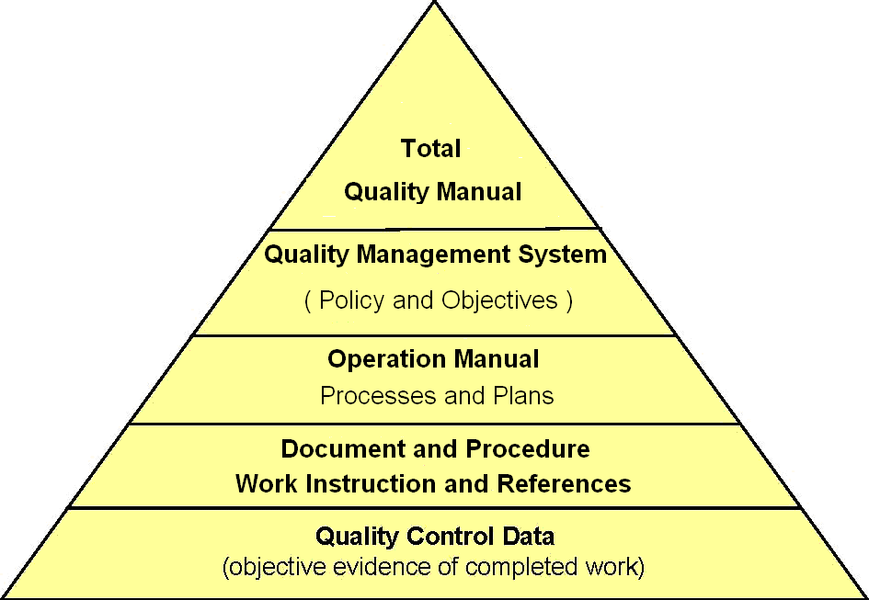

- Total Quality Manual: Is the complete Quality system for all operations applied within the Company.  - Quality Management System Manual: Details the Quality Policy and Corporate Objectives as required by the ISO 9001:2015. It describes the structure of the Quality Management System, broadly outlines the organization and key Management responsibilities. It also describes the processes for management of the system.  - Operations Manuals: Contain individual process documents, procedures, work instructions, internal specifications and checklists pertaining to the business operations. There will also be a manual of operational processes and instructions.  - Documents, Procedure, and Work Instruction: it shows samples of each manual form, how to do? And where?  References: may be External (e.g. Standards, Machine Operation Manuals etc...) or internal (e.g. price lists, vendor lists, drawings etc…).  - Quality Control Data: Evidence that the Quality Assurance System is working. They include completed forms, reports, minutes of meetings etc. | 4, 5, 6 and 8  7
Scope & Exclusions

SCOPE AND EXCLUSIONS

Scope | - The application of this process at the time of executing of any procedures / instructions and filling-up of any document by the personnel involved in the preparation / amendment.  And reviewing procedures / instructions and those responsible for the approval and adoption as well as those responsible for the distribution of the Different departments of coming fields.  - All of our operations in the manufacture and the supply of metal doors and the supply of traded architectural items.  The Company will provide some variation of door specifications if required by the Customer but we do not undertake fundamental design activities.  - It also Applies to the trading services of various types of tools & equipments for major projects, in addition to installation and service after sale, and supplying the related accessories and spare parts.  Beside that; offering complete installation of petrol station.  The Company Management intends that the business objectives, strategies, tactics, and processes used to realize these scopes always satisfy applicable customer, regulatory, and statutory requirements.  The TQM is based on implementing measurable and Customer focused business processes which form a basis for continual improvement. | 4.2.2 a
Exclusions | The Aldrees quality management system excludes the 8.3 design clause of ISO 9001: 20015.

Statements

MISSION, VISION, VALUES, OBJECTIVE STATEMENTS

AND STRATEGIES

Mission | AlDrees is a multi-scope corporation engaged in Metal doors & Frames and the trading services of various types of tools & equipments for major projects in Middle East. It is dedicated to attract and attain the customer by delivering reliable quality of our high- valued products and services, and the most satisfying, while our employees and business partners will share in our success and our stock-holders will receive a sustained superior return on their investment.
Vision | Our vision is to become one of the leaders of multi-scopes companies in Middle East, In order to achieve this vision, we recognize that many objectives must be attained and be integrated into daily business objectives and future planning activities.  And we have to continually monitor the quality of our supplies and the performance of sub-contractors as they contribute significantly to the overall performance of the business.  And to ensure that our staff are competent and to develop our employees' skills and talents to increase the benefits for them and to the company. This is brought about by careful recruitment and by providing adequate training.  So that we can become a more sustainable company and adding more scopes.
Values | The diversity values at AlDrees are:  Thinking and acting regionally. AlDrees employs a multicultural workforce that generates innovative decision-making for diverse customers and partners.  Innovating; Innovation helps lower the costs of manufacturing, trading and related services.
Objectives | MAIN OBJECTIVES:  Is Middle-East domination, with regard to supplying metal products, Trading services of various types of Tools & Equipments,  ECONOMIC CONTRIBUTIONS  AlDrees reorganized its local joint Divisions into one company, to acquire a highest market stake for the products of its scopes, to enhance its operations to achieve the global standards, and to convert into stock-market as an opened joint-stock company  Statements  *Expanding Employee Training  To ensure that the operations develop unhindered, AlDrees is expanding its employee training programs. The AlDrees training center, based at the head office, is responsible in training and follow-up the competencies of the employees.  And are supported by quantified objectives at departmental and operational level.
Strategies | Aldrees diversity and inclusion strategy is an important part of our business priorities. We are working with executives across the company to support and drive our efforts. The pillars of our diversity and inclusion strategy are:  Driving leadership accountability and ownership  Attracting, developing, and retaining a diverse workforce  Creating a culture and climate of respect and inclusion.

QUALITY POLICY AND
Quality Policy & Objectives

QUALITY OBJECTIVES

Quality | Quality is the degree to which customer requirements for AlDrees products and services are identified and satisfied
Quality Policy | Management’s policy for quality:  Satisfy customers first.  Provide competitive solutions for customers.  Comply with customer and regulatory requirements.  Improve continuously. | 4.2.1 a  5.1 b  5.3 a-c
Quality Objectives | Company measures and continually improves the degree to which customer requirements and the quality policy are satisfied.  Management establishes goals for product conformity and process effectiveness to accomplish these ends. These include goals for the business processes described in this manual.  Product conformity is measured by tracking final test yields. (Note: Yields and yield standards (goals) are strictly proprietary.)  Process effectiveness is measured by comparing actual results to expected results, or by resulting product conformity.  Typically, many metrics may be established for a given product or process. Any metric which meets the criteria in this section may be used as audit evidence for established quality objectives. | 4,2,1 a  5.3 b, c  5.4.1  7.1a

Requirements

REQUIREMENTS

Planning | Top management is responsible for ensuring that the requirements of this Manual are implemented and administered. | 5.4.2 a
Delegation | The management representative for quality may delegate administrative duties (but not responsibility) of the quality system to the Quality Department.  Each business process in this manual is assigned to a specific department(s) for administration. Managers may designate process owners for facilitation.  Executive management retains authority to ensure establishment and ownership of the processes in this manual. | 5.5.1
Administration Requirements | Management Representative, acting for top management shall:  - Document the quality policy and explain how management sets quality performance objectives for products and the business processes  - Identify the business processes used to identify and meet customer, regulatory, and statutory requirements.  - Define the sequence and interactions that allow quality manual processes to function as a system.  Designated process owner shall:  - Document the procedures needed to operate and control each business process effectively  - Monitor, measure, and analyze the processes to ensure achievement of planned results and continual improvement  - Assess and provide the information needed to operate, monitor and control each business process  - Make the procedures comply with ISO9001:2008  - Plan and implement needed changes  - Maintain integrity of the quality system | 4.1 a  4.2.2 b  4.1 c  4.2.2 c  4.1 b  4.1 d  4.1  4.1 e  4.1 f  4.1  5.4.2 a, b  5.3 a-e
Documentation  Requirements | Document a quality manual that defines scope, exclusions, and procedures for the quality management system, and interaction between the quality system processes.  Requirements  Document AlDrees quality policy and quality objectives in the quality manual.  Document the business processes used to identify and meet customer, regulatory, and statutory requirements in the quality manual. Include any processes needed to fulfill the quality policy, meet the quality objectives, meet customer requirements, and implement the requirements of ISO9001:2008.  Documentation is developed when and where necessary – and in the appropriate medium - to provide the necessary level of quality assurance. The structures of the system are described before and in our process for document control (see also the list of processes in APPENDIX II). Controls are established for Review; Approval; Change and Distribution.  We ensure that our Quality System documentation is legible and easily understood; is properly indexed, filed, readily retrievable and protected against damage deterioration and loss.  The retention time and disposal authorities for all records are 5 years - and documents existing in electronic media are subject to access security and back – up where required. | 4.2.1 a-d
Record Requirements | Ensure that records specifically required by ISO9001:2008 are required by the appropriate quality manual chapters.  These include:  1) Evidence of conformity to requirements  a. For product & services(at development and production)  b. For quality system processes  2) Evidence of effective quality system operation  3) Management reviews  4) Personnel training, skills, experience  5) Product & Services realization planning  6) Review of customer-specified requirements  7) Product design requirements  8) Review of design results versus requirements  Requirements  9) Design and development verification  10) Design and development validation  11) Design and development changes  12) Supplier evaluation, selection, performance  13) Validation of non-verifiable production processes  14) Validity of measurement on un-calibrated equipment  15) Internal audit results  16) Authorized release of nonconforming product  17) Nonconforming product and subsequent actions  18) Corrective actions & Preventive actions | 4.2.1 e  4.2.4  4.2.4  5.6.1  6.2.2e  7.1d  7.2.2  7.3.2  7.3.4  7.3.5  7.3.6  7.3.7  7.4.1  7.5.2  7.6  8.2.2  8.2.4  8.3
Commitment Requirements | The Management Representative shall provide auditable evidence of top management commitment to develop, implement, and continually improve the quality system, as follows:  - Organization-wide communication of the importance of customer, statutory, and regulatory requirements.  - quality policy and quality manual  - quality objectives and results  - management reviews  - resource needs and availability | 5.1  5.1 a-e
Management Review | At least two Management Review meetings are held annually to a minimum agenda shown in (APPENDIX III) for each Division.  They are chaired by the Divisional Manger and attended by the heads of department and other personnel as appropriate to the agenda and discussion.  Minutes of the meeting are taken which detail any agreed actions to achieve continual improvement | 5.6.1  5.6.2  5.6.3
Resources Requirements | We ensure that we employ competent and trained staff - and we have systems in place to identify recruitment and further training needs as well as the effectiveness of the training given. In addition we also ensure that all personnel are aware of their contribution to Quality.  Requirements  It is our policy to provide the necessary resources such as plant, equipment, buildings and utilities to ensure they are appropriate to the type of work and to maintain, as far as is reasonably practicable, a suitable and safe working environment.
Customer Focus  Requirement | All bids and contracts are reviewed to ensure that; the requirements and expectations of our Customers are fully understood and respected, including specific requirements for delivery of special importance of the review and recording of all contract variations.  Our policy is to continually communicate with our Customer – mainly through our Sales department - to ensure that we are always aware of the level of Customer satisfaction  The Management Representative shall provide auditable evidence that business processes for order entry, contract administration, and product development include procedures for determining customer requirements and converting them into work instructions with a view toward enhancing customer satisfaction. | 5.2
Procurement Control | To ensure first class services to our Customers, we provide our Suppliers and Subcontractors with full specifications of our requirements and we monitor their performance.
Products and Services Policy | Provision of our products and services are usually on specified schedules and we ensure that we are able to fully meet these by control of our manufacturing processes and stock levels.  For production elements that are difficult or impossible to fully verify (eg spot welding), systems are established to ensure that they achieve the correct result. In addition to ensuring that all equipment is suitable and persons involved are fully qualified, we also check the standards that apply and arrange for any necessary pre-qualification tests.
Identification and Traceability | It is our policy to ensure that methods are established for identifying all materials, products and services. Also, all status parameters for inspection, test and other measurements are identified at relevant stages and records are maintained. Where necessary, systems are established to provide for full traceability to source.
Handling and Care | Throughout our operations systems; are established to ensure that all goods, materials and products are properly protected from damage, deterioration and loss.
Monitoring and Measurement | Systems are established for monitoring, measurement and analyzing of process capability and the quality of our products and services. This enables us to measure performance against objectives; to measure quality against defined criteria and ensures that we have a basis for continual improvement.  Requirements  We also ensure that our products and services are investigated and checked at defined stages or otherwise as required by the Customer. All equipment used for monitoring and measurement is controlled and calibrated to national or international standards - in order to continually provide the required accuracy and precision.
Non-conformance Control and Continual Improvement | Documented systems are established to ensure that all nonconforming products are identified and prevented from being used until decisions are taken as to concession or disposal.  There are also documented systems established to investigate problems and concerns that do arise with the products and services that we supply - and within the TQM itself - to ensure that they are fully investigated, and appropriate corrective and preventive action is taken.  Prevention is part of our business culture and all personnel are encouraged to identify and report problems, potential problems and other concerns. Measures are taken to reduce the risk of problems arising especially in those areas of our business dealing with critical areas of product safety.
Quality Policy  Requirements | The Management Representative shall provide auditable evidence that the quality policy is communicated and understood within the organization and that it is reviewed annually for continued suitability.  In establishing and reviewing the quality policy, we ensure that:  1. It is appropriate to the purposes of AlDrees Corporation  2. It includes a commitment to comply with quality system requirements and to continually improve quality system effectiveness  3. Quality objectives consistent with achieving the goals of the quality policy are established and reviewed | 5.3 a-e
Internal Communication  Requirement | Top management ensures that communication takes place regarding the effectiveness of the quality system in top level reviews, such as quality system management reviews, operations reviews, quarterly business reviews.  Top management ensures that appropriate internal communication processes are established within the quality system business processes.  Requirements  Systems are also established for communicating with, and caring for our Customers, mainly through our Sales function.  Due to the nature of the product or services it is our policy to ensure correct specification and continual improvement to enhance Customer satisfaction and improve our performance.  Policies and Quality objectives relevant to our business are established, and these together with the systems to implement them are communicated throughout the organization. | 5.5.3

RESPONSIBILITY AND AUTHORITY
Responsibility & Authority

 | Responsibilities for the quality system are assigned functionally in the Quality Management System (QMS) Organizational Chart. These apply regardless of the departmental organization of the company.  The Total Quality Manual (TQM) is used to communicate these responsibilities.  Authority for review and approval follows normal departmental hierarchy. Signature authority defined and used by management for financial approval applies.  A department(s) is assigned as process owner for each process in the quality manual. The owning department(s) maintains the process documentation, and is accountable for implementation, operation, control, effectiveness, and corrections. | 5.5.1
For detailed responsibilities of specific business processes, such as Sales and Purchasing,,, etc, responsibility and authority are specified within the process.

the key management responsibilities for quality in divisions are as follows:-

Chief Executive Officer | AlDrees Chief Executive Officer of operations functions as the executive Management Representative for Quality.  He has overall responsibility, authority, and accountability for the quality system.  Duties includes; He must ensuring that:  - Establishing Corporate Objectives and Quality Policy.  - Quality system processes are appropriately documented, implemented, and operated.  - Performance and opportunities for improvement are reported to top management.  - Awareness of customer requirements is promoted throughout the organization.  The Quality Department supports the Chief Executive Officer in carrying out these duties.
Divisional Manager | - Ensuring that supportive business objectives and processes are established.  - Executive review of Quality and chairing Management Review meetings.  - Ensuring that suitable resources (including plant and equipment) are provided.  Responsibility & Authority  - Ensuring that responsibilities and authorities are defined and communicated throughout the Division.  - Ensuring that Customer and regulatory issues are communicated throughout the Company.  - Control of recruitment, training and monitoring human resources.
Quality & Development Manager (QDM) | - Maintaining the Total Quality management System  - Ensuring that the Company's Quality Policies and Systems are properly documented  - Controlling and issuing the Quality System Documentation  - Ensuring that all personnel are aware of Quality and Customer requirements  - Carrying out/arranging internal quality audits  - Reporting to the Management on the performance of the Total Quality Management System.  - Ensuring, together with the Sales Manager that the Customer Feedback process is properly implemented and measured
Human Resources Manager | - Establish company Human Resource targets & Policies.  - Responsible to ensure all company transactions submitted to Government department.  - Conduct internal & external training Programs as per various department requirements.  - Ensure the Legislative Rights & Government laws that bear relationship between employees and the company.  - Govern the recruitment policies and participate in interviews if necessary.
Marketing & Sales Manager | - Ensuring, together with the Administration Manager that the Customer Feedback process is properly implemented and measured  - Reviewing enquiries and contracts and developing bids  - Ensuring that contract requirements, including variations, are fully documented  - Ensuring that the projects are executed and all deliverables realized according to plan  - Resolving any enquiry and contract issues with the Customer
Operation Manager | - Control of production operations  - Ensuring that all plant and equipment is suitably maintained  - Ensuring that a safe working environment is maintained  - Planning and issuing the work  - Warehouse operations – via the Warehouse Supervisor  - Inspection and testing  - Ensuring measuring equipment is suitably calibrated and records are maintained
Finance Manager | - Ensure Proper Cash Management  Responsibility & Authority  - Ensure timely and relevant Financial reporting  - Management of Finance Personnel  - Management of Computerized systems  - Ensure proper Inventory Management  - Ensure proper implementation of internal controls  - Advises management with regards to financial issues
Purchasing Manager | - Maintains a professional database record of Approval List of Suppliers, Products and Price Lists.  - Negotiates with approved suppliers the best price possible for door hardware and materials needed, to achieve safe budget margin.  - Places Purchase Orders for projects, stocks and production.  - Coordinates with suppliers and freight forwarders the delivery date of items ordered.  - Ensures that goods and materials purchased are in accordance with the highest quality standard set by the company.
Q/A & Q/C Manager | - Ensures that products produced conform to standard quality set by the company.  - Segregates produced products that do not conform to the standard quality set by the company, and locate in the Hold Area.  - Coordinates with Warehouse personnel and checks the quality of raw materials or factored products being delivered in the loading bay. Receives good conforming materials only, and confines non-conforming materials in the Hold Area.  - Ensures for proper actions against the Non-conforming Reports.  - Checks and ensures that Safety Precautionary Measures are being followed by factory staff.

SYSTEM DOCUMENTATION CONTROL
System Documentation

Introduction
This process ensures that all TQM documents are reviewed, approved and distributed so as to be in the correct place; used by the correct people; for the correct job at the correct time.

For forms; This Process is only controlling the manual Forms if not available on ERP system. Regarding the e-forms attached and generated from ERP system; it is controlled by system itself because no way to use any other revision instead of using the last revision.

Records
Computer data Back-up Logs
DCR Log
Document Change Request (DCR)
Document Fly Sheet
Document Master Register
Records Register
References Register

Process
New documents circulated for comment are marked “DRAFT”. Once approved; it will be uploaded and published on the ERP System. Documents will be stamped with UNCONTROLLED COPY stamp if it has been printed, and should only be used for assisting in auditing, document revision and issue to external parties. Documents stored in electronic media must be password and back- up protected; NO UNAUTHORISED COPIES ARE ALLOWED.

In the cross functional process maps, the shaded function is that responsible for managing the process.

Document Identification System
The document identification system is as follows

Process Categories
System Documentation

DOCUMENT CONTROL  INTERNAL AUDIT  CONTROL OF NONCONFORMITY  CORRECTIVE AND PREVENTIVE ACTION  CUSTOMER FEEDBACK  MANAGEMENT REVIEW  HUMAN RECOURSES  ACCOUNTING  BANK NOTES  CHEQUES  FINANCIAL  FIXED ASSETS  SALES & MARKETING  CUSTOMER  PURCHASING  SUPPLIER  PRODUCTION  WORKSHOP  INVENTORY  SUPPLIES  CALIBRATION AND MAINTENANCE  QUALITY | QMS  QMS  QMS  QMS  QMS  QMS  PAY  ACC  BNK  CHQ  FIN  FAS  SAL  DEB  PUR  CRD  PRD  WSH  INV  SPL  CAL  QLY

Process Notes:
Note 1
System Documentation

The Department Manager reviews the DCR (with other departments if applicable). If not accepted, writes a comment on the DCR and return to requestor for revision or termination.

Note 2
A new or revised master document is produced. The whole document is updated with new revision number for each change – except for manuals where only the affected pages are changed.

For all internal TQM documents except the forms and references:
Update the document master register and Upload the secured (to prevent any misuse) e-document to the system for distribution stamped with stamp of "UNCONTROLLED COPY" if it has been printed, and make sure the accessibility for the users of this document only, and insert a hard-copy in the Master File, and copy to the Master Compact Disk (CD) without stamp and unsecured to be updatable, and remove the superseded document from the system. Retain the superseded copy for possible future reference, and then send an internal memorandum, e-mail, or fax to inform the involved staff according to the distribution list on the Document Master Register.

FORMS
Update the Records Register and Upload the e-document to the system for distribution and insert a hard-copy in the Master File, and copy to the Master Compact Disk (CD). Send an internal memorandum, e-mail, or fax to inform all of users with the update and the form use must be started with the sending date, and make sure the accessibility for the users of this form only, and the old forms are retrieved and removed – allowing a reasonable period of overlap if necessary. Again retain a copy in the Master File.

REFERENCES
External references are documents to which we work but do not control. They include National and International Standards, Product Data Sheets, Operation and Maintenance Manuals etc.

Changes to reference documents are routed via the QMR and ensures that an entry is made on the appropriate Document Fly Sheet attached to the individual reference manual or file.

RECORDS CONTROL

The QMR maintains a Records Register, which identifies location and retention period. Records are mainly internally generated, but appropriate records from suppliers (e.g. Delivery Notes), Customers (e.g. Orders), and regulating authorities (e.g. Test Reports) are also included.

Records shall be clear, legible and identifiable to the subject concerned. The holder of the records shall ensure that they are identified, indexed, and filed in the correct location.

Persons who hold records must also ensure that they are readily retrievable and stored in a suitable environment to minimize the risk of deterioration, damage or loss. They must be held for the period identified on the Records Register and authority for disposal shall also be identified.
Note: Revision status of forms is also recorded on this register.

Main Process DOCUMENT CONTROL
System Documentation

For Quality Manuals, Processes, Procedures, Work Instructions and Forms
Key Performance Indicators
Ref | Indicator | Data | Responsibility for Analysis | Analysis period
1 | Cycle time for document approval | From receipt of DCR to document issue | QDM | 6 months

INTERNAL AUDIT SYSTEM
Internal Audit System

Introduction
This process describes how internal quality audits are scheduled, carried out, reported and closed to ensure the effectiveness of the Total Quality Manual (TQM).

Records
Audit Checklist
Audit Schedule Action Report
Action Report Log

Process
Internal Audits are carried out by trained auditors (who are independent – preferred not a must to have a back knowledge and related operations - of the area(s) being audited) in order to test the effectiveness of system implementation. A schedule is set up to ensure that the system is audited, dependable, and reliable at least one per year (for the main processes in the system and the weak operations it is preferred to make an audit more and more during a year until making sure that the operation has been operated conform with the quality management system). Unscheduled audits may be carried out when necessary – e.g. when:

• There is a need for a follow up audit
• There have been significant changes to a process; organization etc… in a particular area
• Problems in a particular area arising out of a survey by the Third Party body

The overall results are reviewed approximately every 6 months to give an overall view of the TQM for Management Review.

Process Notes:
Note 1:
The audit schedule is set and established to cover the whole system at least one time per year. Extra unscheduled audits may be carried out when necessary – e.g. when there are significant changes to the system etc. Internal auditors must be trained in auditing and independent – preferred not a must to have a back knowledge and related operations - of the area(s) they are auditing. Audits may be carried out with individual auditors or in teams of two, depending on circumstances.

Note 2
If the action has not been completed or is ineffective, the process of correcting the nonconformity must be repeated from an appropriate stage or escalated. This may involve raising another ARP or escalating a MINOR NC to a MAJOR for example.

Note 3
Update the audit status, review the ARPs and observations for trends etc and report overview of results to Management Review.

Main Process INTERNAL AUDIT
Internal Audit System

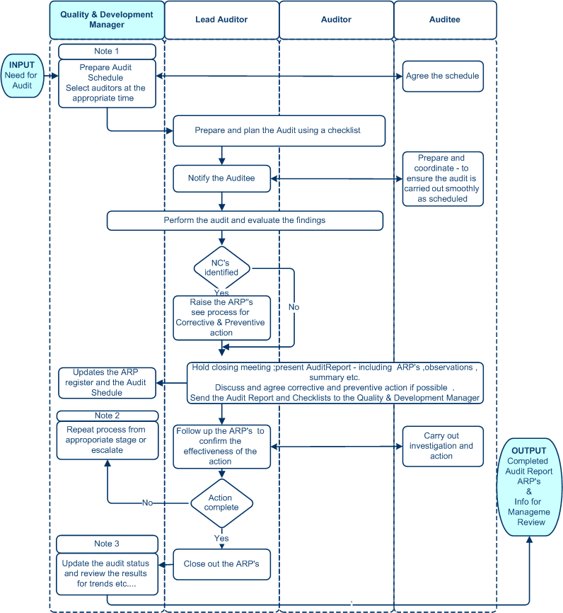

Key Performance Indicators
Ref | Indicator | Data | Responsibility for Analysis | Analysis period
1 | Percentage of audits carried out on time | Schedule | QDM | 6 months
2 | Percentage of Corrective and Preventive Actions carried out on Time | Action Report Log | QDM | 6 months

CONTROL OF NONCONFORMITY
Control Of Nonconformity

Introduction
To describe the control of nonconformity relating to the product and services we provide. The objective is to ensure that all nonconformity is identified at all stages of our operations and disposed of in a controlled manner in order to prevent inadvertent use.
Note: Nonconformities in the TQM are dealt within the Internal Audit and Corrective & Preventive Action processes.

Records
Concession Note
Concession Register
Action Report Log
Action Report
Nonconformity Log
Nonconformity Report
Inspection and test reports

Process
Nonconformities may be identified at any stage of the operations and will include, for example, materials and spares received, rejects arising from inspections during the project, assembled units and Customer complaints.

Process Notes:

Note 1
Segregation is either by removing product to an identified holding area – or otherwise disabling the product - to prevent inadvertent use. Identification is by:
- Yellow labeling for hold pending decision
- Red labeling for reject or scrap

The process covers nonconformity in supplies, customer returns and final inspection. In – process inspections and tests are reported and analyzed as required by the specific process. These are reviewed by QC for undue trends and then, if necessary, corrective and preventive action is taken.

Note 2
The QC ensures that a Nonconformity Report is raised for problems with supplies final inspection and customer returns. The report will identify the problem and any remedial action taken.

Note 3
Product that is reworked or repaired must be re - tested from the appropriate stage of our operations.
Control Of Nonconformity

Non–conforming product may be released for use under concession by a relevant authority or by the customer. A fully signed up Concession Note, fully detailing the problem, must be completed, registered and signed off by the appropriate authorities.

Note 4
The Quality & Development Manager shall review the KPI’s and other elements of the NCR’s – with other persons as required - providing information for the Management Review meeting. Any evidence of adverse trends or other systematic problems – or any indication of further potential problems should be used to implement continual improvement measures.

Note 5
The QMR shall ensure that all the necessary actions are carried out and the ARP closed off. The action may involve any person, depending on the circumstances. On occasions it could include customers and suppliers.

Main Process CONTROL OF NON-CONFORMITY
Control Of Nonconformity

Key Performance Indicators
Ref | Indicator | Data | Responsibility for Analysis | Analysis period
1 | % Reduction of NC’s | No. of NC’s during period - categorized | QDM | Quarterly
Corrective & Preventive

CORRECTIVE AND PREVENTIVE ACTION

Introduction
It is company policy that management applies formal actions where necessary to correct nonconformities or potential nonconformities within the system, processes, products and customer service. This process defines the manner in which corrective and preventive actions are planned, carried out and reviewed.

Records
Action Report Log
Action Report (ARP)
Nonconformity Report (NCR)
Problem / Concern Note (PCN)

Process
Corrective action is taken to correct actual nonconformities and to remove the cause to avoid recurrence. Preventive action is taken where a potential nonconformity has been recognized but no nonconformity currently exists. Both activities form a vital part of continual improvement. Information comes from Audit Reports, Inspection Reports, Concerns and reports on nonconforming products and services – including problems with supplies and subcontractors. The output provides information for analysis for continual improvement.

Process Notes:

Note 1
The Problem / Concern Note (PCN) is completed by any person who thinks there may be a problem or potential problem that has not been picked up as nonconforming product, customer complaint or as an audit finding. This is reviewed by the respective Manager or Supervisor before being passed to the QMR.

Note 2
The QMR reviews the NCR’s, Inspection Reports and PCN’s with the relevant parties and if further investigation is required he raises an ARP.

Note 3
For Audit Reports, the results are normally analyzed at the time by the Auditors and the ARP’s are presented at the Closing Meeting in accordance with the Internal Audit process.
Note: Nonconformities and observations resulting from audit are both recorded on the ARP.

Note 4
Action is carried out as identified on the ARP. If it is not completed on time or shown to be ineffective – the Quality & Development Manager and relevant persons discuss the situation and, if necessary, modify the action or maybe raise a new ARP.

Note 5
Follow up is normally carried out by the QMR together with the relevant persons. In the case of audits, the Auditor is the main person to follow up the audits.
Corrective & Preventive

Note 6
The Quality & Development Manager shall review the KPI’s and the ARP’s to provide information for the Management Review meeting. Any evidence of adverse trends or other systematic problems – or any indication of potential problems (e.g. from concerns and observations) should be used to implement continual improvement measures.

CUSTOMER COMPLAINTS

An Action Report (ARP) MUST be raised for any justified customer complaint. More detail on how to deal with customer complaints is found in section 11.0 of this manual.

Main Process CORRECTIVE AND PREVENTIVE ACTION
Corrective & Preventive

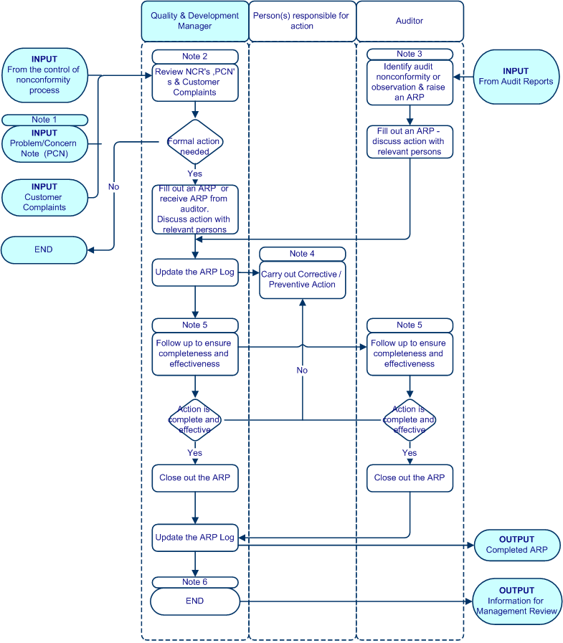
Key Performance Indicators
Customer Feedback

Ref | Indicator | Data | Responsibility for Analysis | Analysis period
1 | % Reduction of ARP’s | % during period | QDM | Quarterly
2 | % of ARP’s closed within agreed time | % during period | QDM | Quarterly

CUSTOMER FEEDBACK

Introduction
It is the policy of the company to analyze all customer feedback & complaints in order to provide part of the data necessary for analysis and improvement of customer satisfaction. This process defines the manner in which customer feedback & complaints are received, recorded and acted upon.

Records
Action Report
Customer Complaint form
Customer Complaint Register
Customer Survey Questionnaire
Customer Survey Register
Nonconformity Report

Process
The process map shows, independently, the processes for handling customer complaints and analyzing customer feedback from the questionnaire.

To effectively centralize customer satisfaction issues, the Quality & Development Manager shall be responsible for maintaining the Customer Complaint Register and the Customer Complaint records.

For customer survey or feedback the sales coordinator, sales supervisor or customer service officer issues customer survey questionnaire to relevant salesman as per customer list and enter into customer survey register. Salesman sends the forms to customer for feedback then return the forms to sale coordinator, sales supervisor or customer service officer after the feedback from customer and sales coordinator updates survey register and forwards the customer survey questionnaire to Quality & Development Manager to analyze the data.

Other feedback shall be taken into account when measuring the customer perception of our products and services. These include:
- Spontaneous expressions of customer satisfaction and other feedback,
- Product Recalls
- Sales Growth
- Contract Renewals
- New Key Accounts and Key Accounts Closures

Process Notes:

Note 1; 1A; 1B
The three areas contain information about customer complaints:

1 - The completed ARP provides information on any investigation, corrective action and preventive action relating to the complaint.
1A - The completed NCR provides information on any products returned from the customer
1B - This provides the raw data on number and category of customer complaints
Customer Feedback

Main Process CUSTOMER FEEDBACK
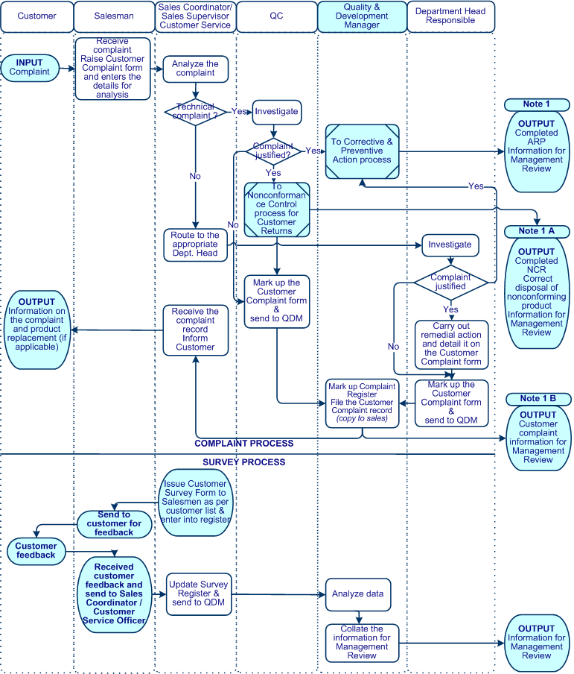
Key Performance Indicator
Ref | Indicator | Data | Responsibility for Analysis | Frequency of Analysis
1 | Customer complaints received within the period | No. of complaints Categorized | QDM | Quarterly
2 | Results of Analysis of Survey Forms | Categorized % | Sales Manager QC and QDM | Quarterly

MANAGEMENT REVIEW
Management Review

Introduction
To define the process for scheduling and holding Management Review of the whole Total Quality Management and reporting and analyzing the results.

Records
Data collection and analysis records
Action Report
Minutes of the meeting

Process
A Management Review shall be scheduled at least twice yearly. It is chaired by the Division Manager and Head of Department with Quality & Development Manager. The minimum agenda and outcomes are as follows:
- Follow up actions from previous Management Reviews
- Results of audits
- Feedback from the customer – including a review of customer complaints
- Overall performance of the main processes within the company
- Level of product and service conformity
- Overview of the status of corrective and preventive actions
- Changes that could affect the quality management system
- Considerations and recommendations for improvement

The meeting will result in an action plan for continual improvement of:
- System effectiveness
- Customer satisfaction
- Process performance
- Product and service quality and
- Resources (as applicable)

The meeting is largely based on the analysis of the process performance data against established targets. The ongoing analysis of data is arranged by the process owner. This information is collated by the Quality & Development Manager for presentation and discussion at the meeting. APPENDIX IV to this manual provides a guide for typical data collection.

APPENDIX I – INTE GRATED BUSINESS PROCESS

APPENDIX II – LIST OF KEY BUSINESS PROCESSES

HUMAN RECOURSES  ACCOUNTING  BANK NOTES  CHEQUES  FINANCIAL  FIXED ASSETS  SALES & MARKETING  CUSTOMER  PURCHASING  SUPPLIER  PRODUCTION  WORKSHOP  INVENTORY  SUPPLIES  CALIBRATION AND MAINTENANCE  QUALITY | QP-PAY  QP-ACC  QP-BNK  QP-CHQ  QP-FIN  QP-FAS  QP-SAL  QP-DEB  QP-PUR  QP-CRD  QP-PRD  QP-WSH  QP-INV  QP-SPL  QP-CAL  QP-QLY

QUALITY MANAGEMENT SYSTEM MANUAL contains

DOCUMENT CONTROL  INTERNAL AUDIT  CONTROL OF NONCONFORMITY  CORRECTIVE AND PREVENTIVE ACTION  CUSTOMER FEEDBACK  MANAGEMENT REVIEW | QP-QMS-M01  QP-QMS-M01  QP-QMS-M01  QP-QMS-M01  QP-QMS-M01  QP-QMS-M01

APPENDIX III – ELEMENTS OF MANAGEMENT REVIEW

The main elements of Management Review are as follows:

- Company organization and continuing validity of the system
- Overall performance of our processes and conformity of our services in line with objectives
- Customer feedback analysis
- Discussion of corrective / preventive actions identified
- Results of previous Management Reviews and Quality Audits
- Adequacy of training and other resources
- Performance overview of Suppliers and Sub-contractors
- Effect on system integrity of planned changes to the organization
- General issues relating to Project Quality Plans for new and potentially new projects
- Recommendations for improvements

This list is not exhaustive and other business may be reviewed as necessary.

The outcome of the Management Review meetings should identify, at least, the actions and resources needed to ensure continual improvement in:

- Customer relations and communication
- Relations with, and performance of, Suppliers and Sub-contractors
- The products and services that we provide
- The effectiveness of our Quality Management System

All resulting actions are monitored by the QDM until satisfactorily closed out.

APPENDIX – IV - TYPICAL DATA FOR MANAGEMENT REVIEW

All data shall be presented in a clear and measurable form. The table below is a guide to typical data for review.
Data | Responsibility | Data Requirement
Follow up from previous Management Reviews | QDM and relevant parties | Elements of the previous action plan  Result’s of ARP’s from previous meeting
Internal Audit Results | QDM | Audits Scheduled  Audits conducted to schedule  Audits closed / open  Audits followed up  Follow-up audits closed out  Audits remaining open  Resource shortfalls  Training needs identified during period  Comparison of performance with objectives set  Need for system changes
Customer Feedback | Sales Manager | Number of Customer complaints received  Number of complaints justified  Product recalls  Other negative feedback  Positive feedback  Sales - repeat and referral business  Sales – lost Customers  Resource shortfalls  Training needs identified during period  Comparison of performance with objectives set  Need for system changes
Process Performance | All | Unplanned plant down-time  Review of current preventive maintenance schedule  Process failures  Resource shortfalls  Training needs identified during period  Comparison of productivity with objectives set  Need for system changes
Corrective and Preventive action status | QDM | Number of ARP’s raised  Number closed out  Number remaining open and why  Number of ineffective ARP’s raised requiring  re-think  Resource shortfalls  Training needs identified during period  Comparison of performance with objectives set  Need for system changes
Non-conformance data | QDM | Number of NC’s raised  Number closed out  Number remaining open  Product recalls  Resource shortfalls  Training needs identified during period  Comparison of performance with objectives set  Need for system changes
Supplier Performance | Purchasing Manager | Number of faulty deliveries from suppliers  Problems with Subcontractor workmanship  Removals from the Approved Supplier List  Potential New Suppliers  Resource shortfalls  Training needs identified during period  Comparison of performance with objectives set  Need for system changes
Changes affecting the system | All | New processes, products and services  New personnel  Policy changes  Other changes
Recommendations for improvement | All | Other recommendation not covered previously
Additional Resource Needs | All | Human resources and other resource needs not covered previously
Training Performance | QDM | Data analyses after completion of training

The Quality & Development Manager is overall responsible ensuring the implementation of this manual although he may not be directly responsible for managing all of the processes and procedures described in this manual.

Relevant performance parameters, records, Standard Operating Procedure, and Process Flow-chart are identified with each individual Procedure.

